CAREER INSIDER SPECIAL EDITION
Job Market Report
In this Special Edition of Career Insider, we review life sciences job market movement in the third quarter of 2025.

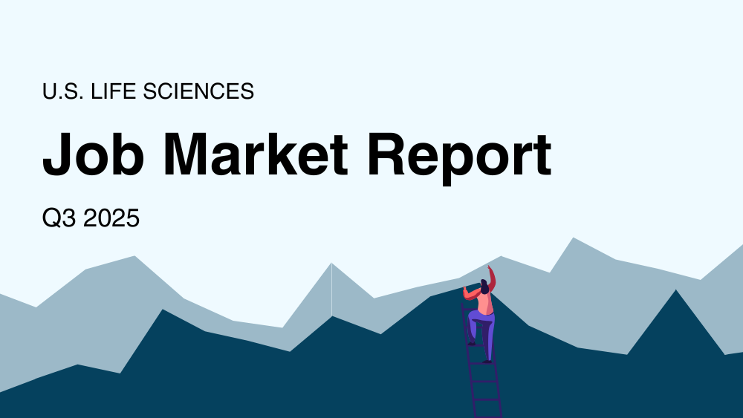
The biopharma job market remains challenging based on BioSpace data showing that job postings live on the website keep falling as layoffs continue, prompting more competition for limited opportunities.

During Q3, jobs live on BioSpace dipped 28% year over year. No other quarter in 2025 had a greater year-over-year decrease. Average jobs live on BioSpace also fell during Q3. They dropped under 3,000 for the first time in the past nine quarters and were down 29% year over year.

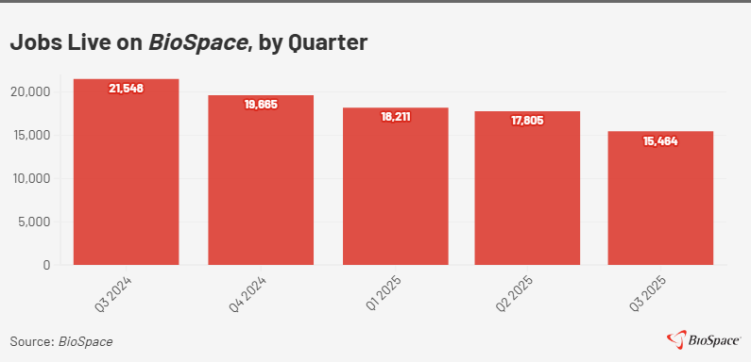
Workforce reductions headed in the opposite direction, with more companies disclosing cuts in Q3 2025 than in Q3 2024—60 versus 47, a 28% increase, based on BioSpace tallies.* Those numbers exclude contract development and manufacturing organizations, contract research organizations, tools and services businesses and medical device firms.

Even more significant is how many employees the workforce reductions will affect. During the third quarter, companies laid off or projected they would lay off about 24,000 employees total. Merck, Moderna, CSL and Novo Nordisk represented a significant portion of those cuts.
- Merck projected it may let go of about 6,000 employees—around 8% of its global workforce—as part of a multiyear process.
- Moderna is downsizing 10% of its workforce, which could affect approximately 550 staffers.
- CSL is cutting about 15% of its employees, which could impact roughly 4,350 people.
- Novo Nordisk is letting go of around 9,000 staffers, which amounts to an 11% cut.
The increased layoffs come at a time when many biotech and pharma professionals are seeking work, based on a July BioSpace LinkedIn poll. It found that 81% of employed and 97% of unemployed respondents plan to look for a new biopharma position in the next 12 months.

Unlock Your Career Potential with Credentials

Biotility’s industry-recognized credentials help you advance your bioscience career by validating your expertise and proficiency to employers. Earn a credential showcasing your knowledge in specialized fields like aseptic processing, quality control, and more.

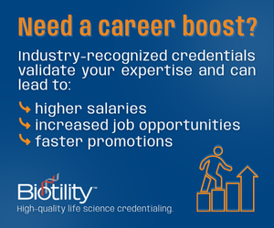
Learn More

BLS, ADP Data Underscore Job Market Concerns
The U.S. Bureau of Labor Statistics (BLS) and ADP have recently shared data showing just how challenging the job market has been. On Sept. 30, BLS reported that in August, the market had not improved year over year. The number of job openings dipped 5.5%, hires decreased 2% and the hiring rate was down slightly, from 3.3% to 3.2%.

The professional and business services sector, which includes scientific services, had more mixed results. BLS noted that in August:
- There were 1.2 million job openings, down 7.3% year over year.
- There were 1 million hires, up 0.5% from August 2024.
- The hiring rate was 4.5%, which represented no change year over year but was higher than the overall 3.2% rate.
Regarding BLS data for September, the agency’s report showing how many jobs the U.S. added as well as the unemployment rate has been delayed due to the government shutdown.

In their response to the Sept. report, Wells Fargo economists wrote, “The latest JOLTS report furthered the notion that the labor market is merely running in place.” They also noted, “With hiring demand still tepid, more workers are opting to stay put in their current job, further tempering upward pressure on wages.”

According to the economists, demand for labor is being hit on multiple fronts: rapid technological change, concerns over the growth outlook following changes to trade and immigration policy and the federal government’s efforts to shrink its workforce.

Immigration policy changes include a $100,000 fee for new H-1B visa petitions, meant to restrict entry into the U.S. by nonimmigrants seeking jobs in specialty occupations. Announced in September, the fee is expected to make it tougher for foreign-born biopharma professionals to work in the United States.

ADP’S latest report also shed light on the job market’s recent challenges. It found that last month, private sector employment decreased by 32,000 jobs, including -13,000 in professional/business services. ADP Chief Economist Nela Richardson noted in an announcement that the numbers validate that U.S. employers have been cautious with hiring.

The news was better for August. ADP reported that private sector employment increased by 54,000 jobs, including +15,000 in professional/business services.

Looking ahead, Wells Fargo economists predicted in an Oct. 3 special commentary that there should be a rebound in job growth early next year.

“That said,” they added, “the labor market's current fragility leaves an uncomfortable degree of downside risks. We recognize it would not take much further moderation in activity to tip the labor market's current state to where it causes more perilous reverberations across the economy.”

Hopeful Signs Amidst Challenges
Not all of the third quarter’s job market news was negative. In late August, BLS reported that data scientist employment is expected to increase 33.5% from 2024 to 2034, making that role the fourth fastest-growing occupation. The top 10 states the agency identified for the highest data scientist employment last year include two with a strong, established biopharma presence: California, which ranked first (36,850), and Massachusetts, which ranked sixth (9,990).

In other positive news for California, in early September, the Los Angeles County Department of Economic Opportunity announced that the state had awarded $23.9 million to LA County life sciences projects to advance inclusive growth and create 10,000 regional jobs by 2030. Those positions include 4,000 within the county.

There has also been continued investment in manufacturing in the third quarter.
- In August, Johnson & Johnson announced a $2 billion commitment to FUJIFILM over the next 10 years that will expand J&J’s manufacturing capacity, creating about 120 new jobs in North Carolina.
- In mid-September, GSK announced it will invest $30 billion in research and development (R&D) and manufacturing in the U.S. over the next five years. GSK expects its new manufacturing investments will create hundreds of highly skilled jobs.
In addition, Eli Lilly started revealing the locations of its four new manufacturing facilities, which are expected to add over 3,000 positions for highly skilled workers, including engineers, scientist, operations personnel and lab technicians. The first site, in Richmond, Virginia, will create 650 high-paying jobs in the state. The next one, in Houston, will bring 615 high-wage roles to the Greater Houston area.

*To tally layoffs, BioSpace compiles data for known workforce reductions. The number of employees affected is identified or estimated primarily through information in company press releases, Worker Adjustment and Retraining Notification Act notices, SEC filings and other media outlets’ reports or via confirmation from company officials.

Not all companies disclose downsizing, and some share only the percentage of staff affected. Some biopharmas provide total numbers retrospectively rather than disclosing individual workforce reductions as they happen.

Job Activity Trends

